

**Institute of Technology of Cambodia**

**Department of Industrial and mechanical Engineering**

Group: I4-GIM (Mechanical)

Assignment : Constructions Mechanical

Lecture: **VOEURN Yong Ann**

Student ID

* BREAN Vanna e20180027
* CHIM Thenggy e20180156
* HA Oudom e20180235
* DUONG Horkmeng e20181355

Academic Year: (2022 - 2023)

**Table of Contents**

1. **Introduction** **2**
2. **Forward Kinematic2**
3. **Inverse Kinematic 4**
4. **Conclusion7**
5. **Introduction**

# Universal Robots is a Danish manufacturer of smaller flexible industrial collaborative robot arms. Universal Robots was founded in 2005 by the engineers Esben Østergaard, Kasper Støy, and Kristian Kassow. During joint research at the Syddansk Universitet Odense, they came to the conclusion that the robotics market was dominated by heavy, expensive, and unwieldy robots. As a consequence they developed the idea to make robot technology accessible to small and medium-sized businesses.

There is a plenty part of this robots such as UR5, UR10, UR3….

1. **Forward Kinematic**

We find end point or some point in joint robot arm by forward kinematic by knowing angle and distance.

z

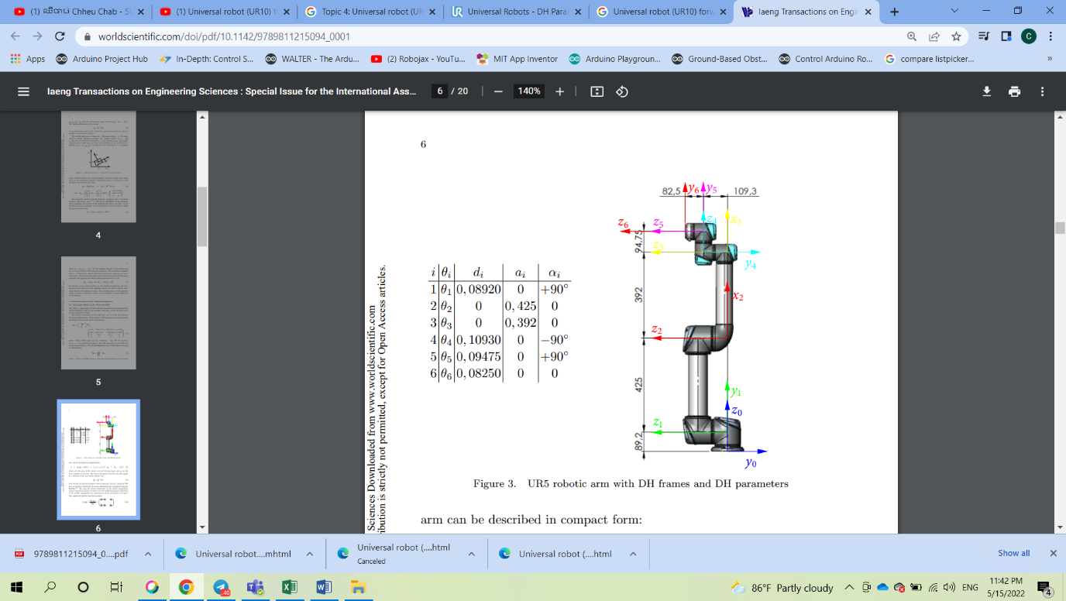

y

x

|  |  |  |  |  |
| --- | --- | --- | --- | --- |
| **Kinematics** | Theta_i | d_i | a_i | Alpha_ i |
| Joint 1 | theta _1 | 0.08920 | 0 | π/2 |
| Joint 2 | theta _2 | 0 | 0.425 | 0 |
| Joint 3 | theta _3 | 0 | 0.392 | 0 |
| Joint 4 | theta _4 | 0.10930 | 0 | -π/2 |
| Joint 5 | theta _5 | 0.09475 | 0 | π/2 |
| Joint 6 | theta _6 | 0.08250 | 0 | 0 |

4 parameters of Denavit-Hartenberg:

link length displacement along from to

link twist rotation around from to

link offset displacement along from to

joint angle from to

)

Therefore, in general for a series of N kinematic links, the overall transformation between the first frame , the base of the first kinematic link, and the last , the end-effector, would be a matrix multiplication of all the D-H transformation matrices:

Where R - corresponds to a 3x3 matrix, representing rotation; 𝑝 ⃗ - corresponds to a 3x1 matrix (vector) that represents translation.

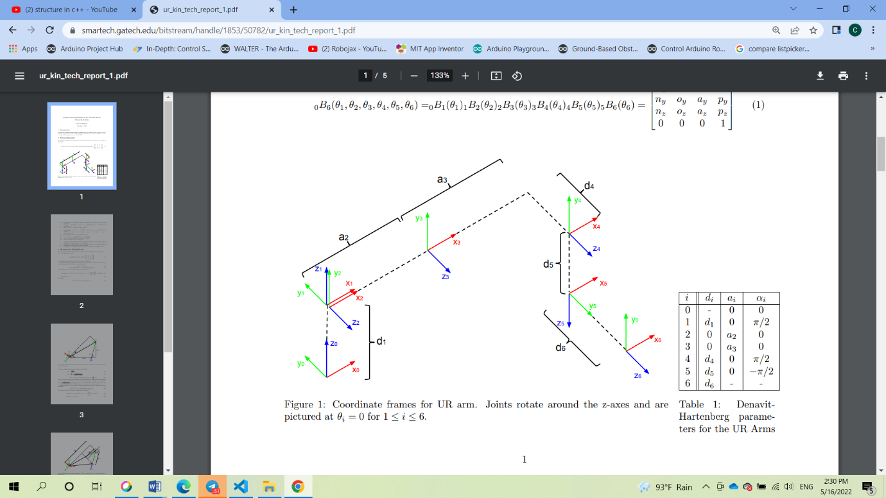We first begin by giving the forward kinematics, describing the position of the end effector as a function of joint angles:

(θ1, θ2, θ3, θ4, θ5, θ6)= (θ1) (θ2) (θ3) (θ4) (θ5) (θ6) = (1)

Figure 1: Coordinate frames for UR arm. Joints rotate around the z-axes and are pictured at θi = 0 for 1 ≤ i ≤ 6.

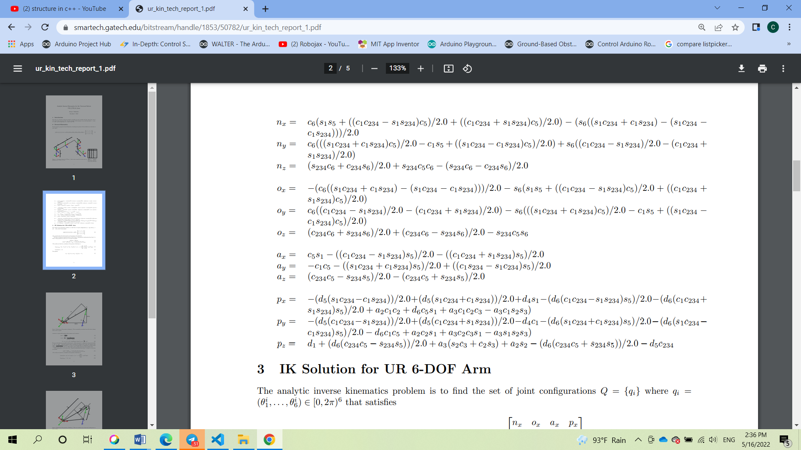

1. **Inverse Kinematic**

Inverse kinematics specifies the end-effector location and computes the associated joint angles. For serial manipulators this requires solution of a set of polynomials obtained from the kinematics equations and yields multiple configurations for the chain. The case of a general 6R serial manipulator (a serial chain with six revolute joints) yields sixteen different inverse kinematics solutions, which are solutions of a 17degree polynomial. For parallel manipulators, the specification of the end-effector location simplifies the kinematics equations, which yields formulas for the joint parameters.

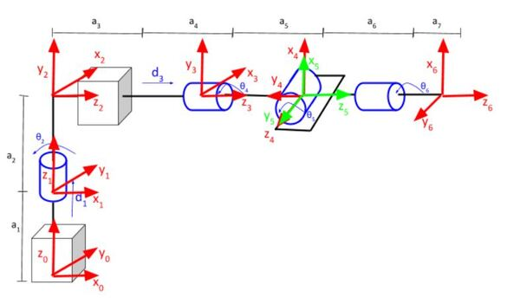For universal robot (UR10), we need to study 6DOF of robot :

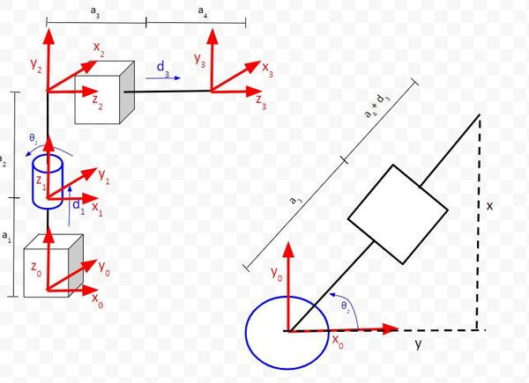The first 3 joints:

we can see that we have two equations that come out of that.

* θ2 = tan-1(y/x)
* d3 = sqrt(x2 + y2) – a3 – a4
* Calculate rot_mat_0_3

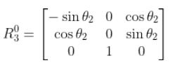

* Calculate the inverse of rot_mat_0_3



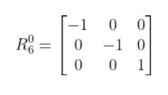

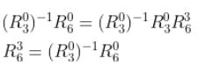

* Calculate rot_mat_3_6

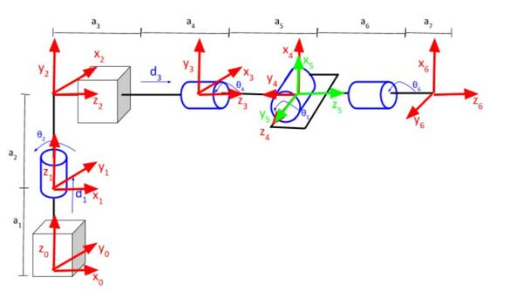To calculate the rotation of frame 6 relative to frame 3, we need to go back to the kinematic diagram we drew earlier.

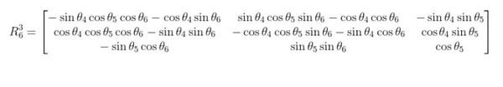Using either the rotation matrix method or Denavit-Hartenberg, here is the rotation matrix you get when you consider just the frames from 3 to 6.

We want to set a desired position and orientation (relative to the base frame) for the end effector of the universal robot (UR10) and then have the program calculate the servo angles necessary to move the end effector to that position and orientation.

1. **Conclusion**

What I’ve shown in this tutorial are two popular methods for calculating a universal robots (UR10) on Forward kinematic and Inverse kinematic. There are Denavitt-Hartenberg Parameters and Inverse Kinematics Analytical Approach.

By using the method, we can learn clearly how to rotation and translation the robot and especially we can use python to solve the equation by using “Numpy” for known a position and orientation of robot.